

**MIDDLE EAST TECHNICAL UNIVERSITY**

**2018**

**DEPARTMENT OF ELECTRICAL AND**

**ELECTRONICS**

**ENGINEERING**

**EE464 Static Power Conversion-II**

**Hardware Project Report**

**Forward Converter Design**

Raşit GÖKMEN - 2339760

Asım Reha Çetin

Instructior : Assistant Professsor Ozan Keysan

**1. INTRODUCTION**

Converters are used for changing the DC voltage level to another one and they are used widely in electronic applications. For example, voltage level of batteries in the cellphones are changed via using DC/DC converters in order to obtain different voltage levels. The other example is that line voltages in the commercial areas are converted via using AC/DC converters in order to obtain desired voltage levels. Since these converters are generally used before electronic circuits, some specific features of these converting circuits must be well designed such as efficiency, voltage ripples, harmonic component generations.

The one−transistor forward converter is the most elementary form of transformer−isolated buck converter. It is typically used in off−line applications in the 100 W − 300 W region. This report note illustrates the approach one would take to design a 48V input 28V/100W output, one−transistor forward converter. Since there is always possibility of fluctuations on the input voltage level and change in the load, a control circuit can be implemented to check whether the output voltage level is applicable. Because of this reason in addition to forward converter, a controller from Texas Instruments named uc1845 is used.

Moreover, after deciding circuit elements and performing necessary tests, we design a PCB circuit. It enables us to obtain more robust and stable product. In the last step we add a cooling fan and heatsink in case of any heating problems. Cooling fan and heatsinks lead our product to work longer time periods.

**2. FORWARD CONVERTER**

**2.1 Theoretical Calculations**

Schematic of the forward converter is on the following figure 1. One can see a transformer has been placed between the input voltage and a buck converter output stage. The power switch (SW) is used to create a rectangular voltage waveform whose amplitude is the input voltage and its duty cycle is the controllable variable. The transformer provides both a step−up or down function and a safety dielectric isolation between the input line and the output load. The major restriction of this topology is the maximum duty cycle must be about 50%. Whenever a core is driven in a unidirectional fashion, that is, current only being driven from one direction into the primary, the core must be reset. Magnetization energy which serves only to reorient the magnetic domains within the core must be emptied, or else the core will “walk−up” to saturation after a few cycles. To do this, one needs to reset the core. Resetting is done by drawing current from a winding during the period when the transformer is unloaded, that is, when the power switch and rectifiers are not conducting. Any winding can provide the reset function, but the higher the voltage on the winding, the quicker the core will reset. Typically, this is the primary winding or a separate reset winding of equal turns to the primary. Current from the reset winding can then be returned to the input capacitor and reused during the next cycle of operation.

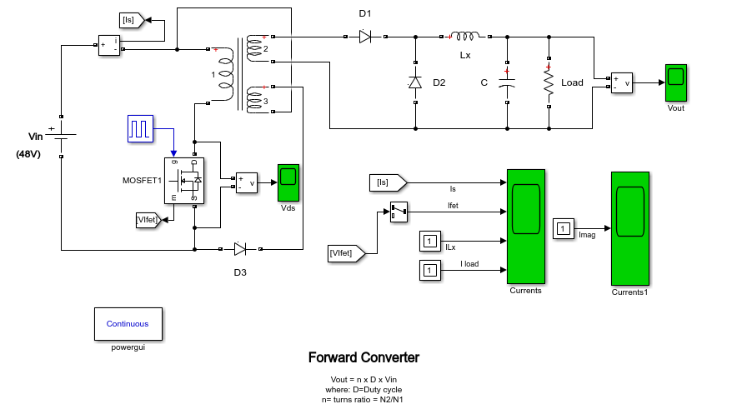

**Figure 1.** Single Switch Forward Converter

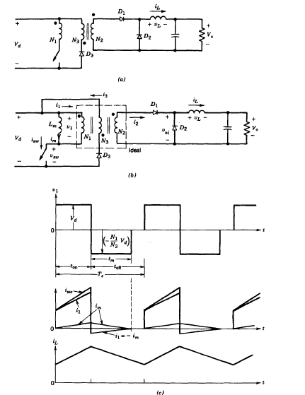

**Figure 2.** Forward converter and it’s corresponding waveforms

When switch is on D1 becomes forward biased D2 becomes reverse biased. Voltage on the inductor, therefore, is

$$Vl=\frac{N2}{N1}Vd-Vo$$

When the switch is off,

$$Vl=-Vo$$

In a one period average inductor voltage is zero, yields

$$\frac{Vo}{Vd}=\frac{N2}{N1}D$$

For the forward converter, magnetizing current of the transformer should be taken into account in order to obtain proper operation. One should prevent the magnetic saturation of the core in the transformer. One way to transfer the stored energy back to the supply voltage is to use practical forward converter topology which can be seen on the figure 2.

When the switch is on:

$$V1=-Vd$$

When the switch is turned off:

$$i1=-im$$

$$N1i1+N3i3=N2i2$$

$$i2=0$$

$$i3=\frac{N1}{N3}im$$

One needs to completely demagnetize the core which means $im=0$, minimum required of time is;

$$tm=\frac{N3}{N1}DTs$$

**2.2 Simulation Results & Equipment Selection**

Simulations are created via using Matlab Simulink. Figure 1 represents forward converter. In the following figure 3, input current above, switch current,output current and inductor current are shown. As seen, output current is constant and inductor current has some ripple. Input current and switch current are same. Figure 4 represents mosfet drain source voltage. This waveform has 3 steps. When the power switch is ON, the switch sees the output filter inductor’s current reflected by through the transformer. The amplitude of the primary current is the output rectifier current times turns ratio of the transformer (N1/N2) plus a small amount of magnetization current. During the power switch OFF time, the switch voltage “flys” up to about twice the input voltage. During this time, the reset winding begins to output magnetization current back to the input capacitor. The output rectification and filter section works identically to the buck converter. The voltage waveform of secondary looks like an inverted primary winding waveform except the zero voltage point is the input voltage point on the primary waveform. The waveform goes positive when the power switch is conducting. The output rectifier also conducts during this time. This presents a unipolar, PWM rectangular voltage signal to the inductor. The catch diode then operates when the power switch and the output rectifier are OFF. Continuous current is then maintained through the output filter inductor.

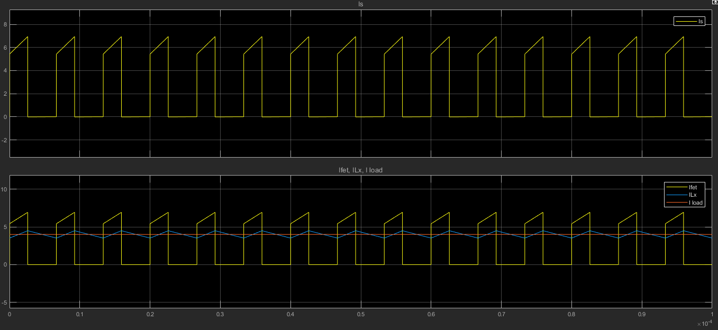

**Figure 3** : Input,Output, Output inductor and switch currents.

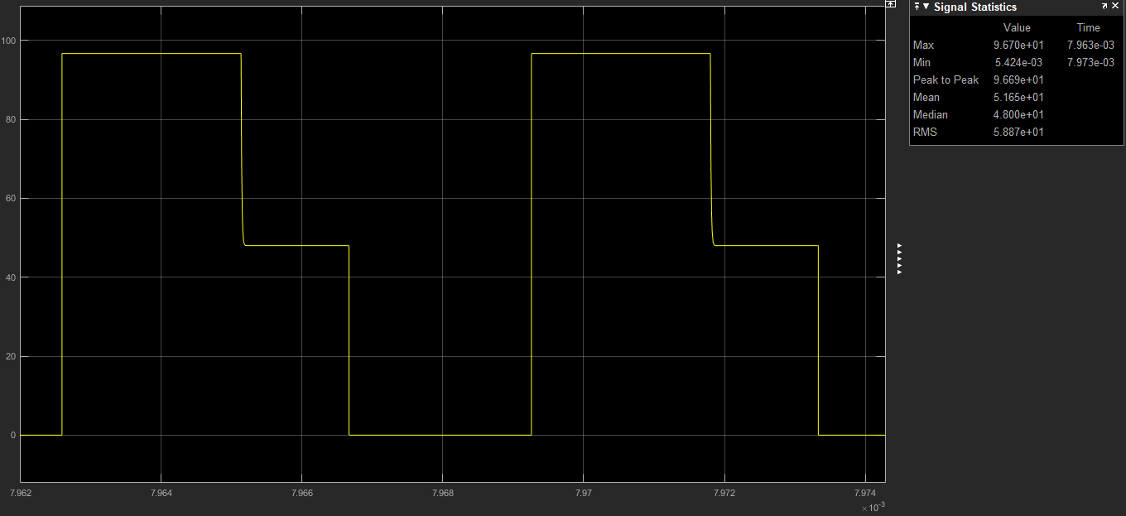

**Figure 4.** Mosfet drain source voltage.

**2.1 Transformer design:**

First select a core family that will house the transformer. A ferrite core N87 with ETD39 coil former from TDK company is selected.

The transformer turns ratio N1/N2 is calculated 0.67. The turns ratio selected 0.6.

Primary turns ratio is selected to be 6 secondary turns ratio is 10.

The core is un-gapped and its parameters given in figure 5.

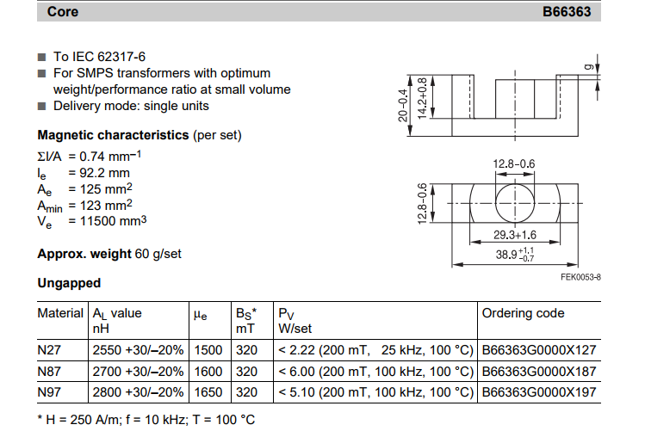

**Figure 5.** EDT39 N87 core parameters [1]

Primary magnetizing inductance :

$Lm = 2700*62 = 97.2 uH.$

Minimum primary turns ratio in order to guarantee saturation:

$n1 >\frac{Vinmax*Dmax*T}{Bsat*Ae}$, $n1 = 3.77$ (our selection is 6)

For $Vimax = 53V$

$Dmax = 0.4$

$Fs = 150 kHz$

$Bsat = 0.3 T$ (max allowed core flux density for ferrites to guarantee non-saturation)

$Ae = 125 mm2$

The turn ratio is wounded with litz wire which has small resistance compared with copper.

The wire is compound of 270x0.05 wire. It has 32.9 ohm/km resistance.

The mean length of one turn for our coil former is 69mm.

At primary:

$N1 = 6 turn$

$Wire length = 6*69 mm = 414 mm = 41.4 cm$

$Wire resistance = 0.414 * 32.9 *{10}^{-3}= 13.6*{10}^{-3} ohm$

At secondary:

$$N2 = 10 turn$$

$Wire length = 10*69 mm = 690 mm = 69 cm$

$$Wire resistance = 0.69 * 32.9 *{10}^{-3} = 22*{10}^{-3} ohm$$

At primary:

$N3 = 6 turn$

$Wire length = 6*69 mm = 414 mm = 41.4 cm$

$Wire resistance = 0.414 * 32.9 *{10}^{-3}= 13.6*{10}^{-3} ohm.$

Llk is assumed %5 of Lmag .

Llk = 0.05*97.2 = 4.86 uH

Llk1 = Llk / 3 = 1.62 uH

Llk2 = Llk / 3 = 1.62 uH

Llk3 = Llk / 3 = 1.62 uH

Minimum load current to ensure CCM operation:

At boundary Io = $\frac{ΔILo}{2}$

output inductor current rises during on period. The min outpur inductor current ripple hence output current is occured at min ton.

$ΔILo$ = $\frac{VL}{Lo}$*ton

VL = $\frac{N2}{N1}$ Vinmax - Vo - Vdiode

where ton(min) = $\frac{Vo-Vdiode}{Vin max}$ $\frac{N1}{N2}$ $\frac{1}{fs}$** = 2,25 us.

where $\frac{N1}{N2}=0.65$

fs = 150kHz

Vinmax = 52.8 V

Vdiode = 0.7V

Vo = 28V

substuting ton value in above equation :

$ΔILo$ = [ $\frac{N2}{N1}$ Vinmax - Vo - Vdiode ] $\frac{tonmin}{Lo}$



$ΔILo$*

= 0.98 A

where Lo = 120uH

Io = $\frac{ΔILo}{2}$ = $\frac{0.98}{2}$ = 0.49 A which is minimum load current with 120uH output inductor to ensure CCM mode of operation.

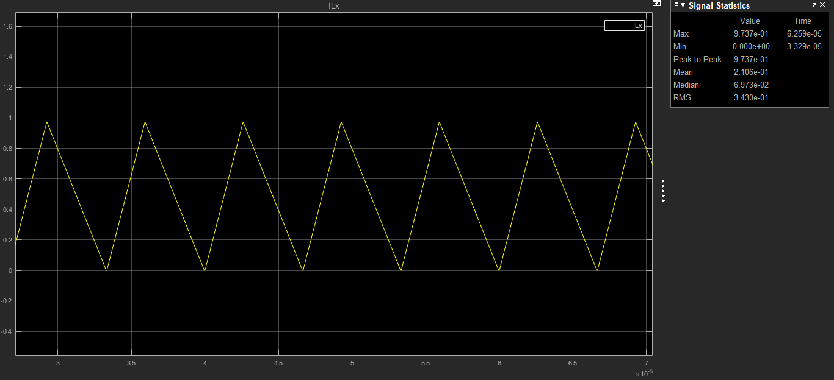

**Figure 6.** Output inductor current at boundary

**Main switch:** As a main switch STL18N65M5 is selected. It has low on resistance. It is features are given below:

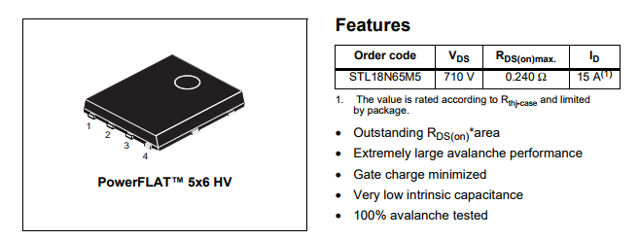

**Figure 7.** Main switch properties

Finally, as an output inductor, 47uH inductor with 8.6A saturation current from Vishay company.

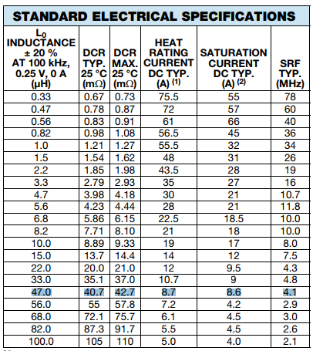

**Figure 8.** Output inductor characteristic

**2.3 Efficiency Calculation:**

At %100 Load :

At %100 load load current is 4A.

Diode1 loss :

Vf = 0.7 V

Idiode = 2.54A

Ploss = 0.7*2.54 =1.778 W

Diode2 loss :

Vf = 0.7 V

Idiode = 3.10A

Ploss = 0.7*3.10 = 2.17 W

Inductor loss :

Irms = 4A

Rind = 42 mohm

Ploss = 4* 0.042 = 0.0168 W

Main mosfet loss :

Irms = 4.52 A

Ron = 0.24 ohm

Ploss = 4.52*0.24 = 1.0848 W

Transformer loss:

Ploss = 22m * 4.52 + 16m * 2.54 + 16m * 0.3 = 0.145 W

Total Ploss = 5.05 W

Efficiency = $\frac{Pout}{Ploss+Pout}$ = $\frac{112}{112+5.05}$ =0.96 = 96%

At %75 Load :

At %75 load load current is 3A.

Diode1 loss :

Vf = 0.7 V

Idiode = 1.91 A

Ploss = 0.7*1.91 =1.34 W

Diode2 loss :

Vf = 0.7 V

Idiode = 2.34 A

Ploss = 0.7*2.34= 1.64 W

Inductor loss :

Irms = 3A

Rind = 42 mohm

Ploss = 3* 0.042 = 0.126 W

Main mosfet loss :

Irms = 3.48 A

Ron = 0.24 ohm

Ploss = 3.48*0.24 = 0.835 W

Transformer loss:

Ploss = 22m * 1.91 + 16m * 3.48 + 16m * 0.3 = 0.1 W

Total Ploss = 4 W

Efficiency = $\frac{Pout}{Ploss+Pout}$ = $\frac{84}{84+4}$ =0.95 = 95%

At %50 Load :

At %50 load load current is 2A.

Diode1 loss :

Vf = 0.7 V

Idiode = 1.29 A

Ploss = 0.7*1.29 =0.9 W

Diode2 loss :

Vf = 0.7 V

Idiode = 1.58 A

Ploss = 0.7*1.58= 1.1 W

Inductor loss :

Irms = 2A

Rind = 42 mohm

Ploss = 2* 0.042 = 0.084 W

Main mosfet loss :

Irms = 2.45 A

Ron = 0.24 ohm

Ploss = 2.45*0.24 = 0.59 W

Transformer loss:

Ploss = 22m * 1.29 + 16m * 2.45 + 16m * 0.3 = 0.7 W

Total Ploss = 3.37 W

Efficiency = $\frac{Pout}{Ploss+Pout}$ = $\frac{56}{56+3.37}$ =0.94 = 94%

At %25 Load :

At %25 load load current is 1A.

Diode1 loss :

Vf = 0.7 V

Idiode = 0.65 A

Ploss = 0.7*0.65 =0.455 W

Diode2 loss :

Vf = 0.7 V

Idiode = 0.79 A

Ploss = 0.7*0.79= 0.553 W

Inductor loss :

Irms = 1A

Rind = 42 mohm

Ploss = 1* 0.042 = 0.042 W

Main mosfet loss :

Irms = 1.40 A

Ron = 0.24 ohm

Ploss = 1.40*0.24 = 0.336 W

Transformer loss:

Ploss = 22m * 0.65 + 16m * 1.4 + 16m * 0.3 = 0.4 W

Total Ploss = 1.79 W

Efficiency = $\frac{Pout}{Ploss+Pout}$ = $\frac{28}{28+1.79}$ =0.94 = 94%

**2.4. Controller Design**

**2.4.1 Theoretical Calculations**

Small signal analysis of the forward converter is as follows.

State equations are as follows:

On state Off state

ẋ = A1 + B1u ẋ = A2x + B2u

y= C1x y= C2x

where u is input.

Averaging them:

ẋ = [A1d +A2(1-d)] x + [B1d+B2(1-d)] u

y=C1d+C2(1-d)] x

Introducing small perturbations as follows (assuming perturbations in input is equal to zero):

x=X+x y=Y+y d=D+d

in steady state ẋ=0 and neglecting products of x and d;

ẋ=AX+Bu+Ax+[ (A1 – A2 ) X+(B1 -B2 )u]d

A = A1D + A2(1-D)

B= B1D + B2(1-D)

In steady state

AX+Bu= 0

Equation 10-50 becomes

ẋ= Ax+[ (A1 – A2 ) X+(B1 -B2 )u]d and

Y+y=CX+Cx+[(C1-C2)X]d

Where

C=C1D+C2(1-D)

Y=CX

y=Cx+[(C1-C2)X]d

Y/U=-CA-1B

Taking lap lace transform of small signal eqn. (10-58)

Y(s)/d(s)=C[sI-A]-1 [(A1-A2)X + (B1-B2)U] + (C1-C2)X

Let’s apply the formula to the forward converter state variables are defined as inductor current and capacitor voltage.

A1= [ -(R*rc + R*rl + rc*rl)/(L*(R + rc)), -R/(L*(R + rc))]

[ R/(C*(R + rc)) , -1/(C*(R + rc))]

A1=A2=A;

B1= [ 1/L ]

[ 0 ]

B2=0;

B=B1*D

For the sake of simplicity assuming R is much greater than (rc+rl);

A=A1=A2= [ -(rc + rl)/L, -1/L ]

[ 1/C , -1/(C*R)]

C=C1=C2=[rc 1];

B remains same.

A-1=1/det(A)* [-1/(C*R ) , 1/L ]

[ -1/C , -(rc + rl)/L]

Small signal transfer function is as follows

$$\frac{U\left(s\right)}{d\left(s\right)}=\frac{1+sCrc}{LC(s^{2}+s\left(\frac{1}{CR}+\frac{rc+rl}{L}\right)+\frac{1}{LC})}U$$

Gain crossover frequency is 70 000 (rad/s). Corresponding phase margin is relatively low. We need to design lead compensator here.

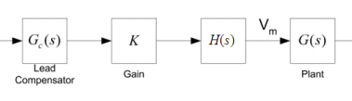

**Figure 9.** Lead Compensator design

H(s) is standing for elimination of steady state error and will be 1/s. K is gain.G(s) is lead compensator which has unity gain. It has a form of

$$Gc\left(s\right)=\frac{a\left(s+\frac{w}{a}\right)}{s+wa}$$

We obtained characteristic of $Gc\left(s\right)*\frac{1}{s}*K$ via using type 2 controller circuit. Overall open loop characteristic is

$$\frac{U\left(s\right)}{d\left(s\right)}* Gc\left(s\right)*\frac{1}{s}*K$$

**2.4.2 Simulation Results**

Let’s choose;

Vd=48V

Vo=28V

rL=0.085ohm

L=94uH

Cout1 = 100uF

rc1=1.2 Ohm

C=30uF

R=1.66 mOhm

fs=200 kHz

$$\frac{U\left(s\right)}{d\left(s\right)}=\frac{1+sCrc}{LC(s^{2}+s\left(\frac{1}{CR}+\frac{rc+rl}{L}\right)+\frac{1}{LC})}U$$

Bode diagram is in following figure 10. Gain crossover frequency $wc=8.88*{10}^{3}$



**Figure 10.** Bode plot characteristic of open loop system.

We designed lead compensator unit here. Let’s start with integrator term in order to eliminate steady state error. Bode plot with H(s)=1/s is following figure 11.



**Figure 11.** Bode diagram of $\frac{1}{s}G(s)$

Choose K=4000; bode plot of K*H(s)*G(s) is in figure 12.



**Figure 12.** bode plot of K*H(s)*G(s)

Let’s design unity gain lead compensator at gain crossover frequency. Bode plot of single compensator is in following figure 13.

$wc=1*{10}^{4}$ rad/s

a=11;

which means we add 80 degrees phase at gain crossover frequency. Our lead compensator has a form of



$$Gc\left(s\right)=\frac{a(s+\frac{w}{a})}{s+wa}$$

**Figure 13.** Characteristic of lead compensator

Overall open loop system characteristic is in following figure 14.



**Figure 14.** Overall open loop characteristic

Figure 14 shows our closed loop system will be stable. As a result we have 39 degrees of phase margin which is enough for proper operation.

In order to control our DC/DC converter we are decided to use UC1845 Current mode PWM controller it has also current limiter. Block diagram of controller is in following figure 15.

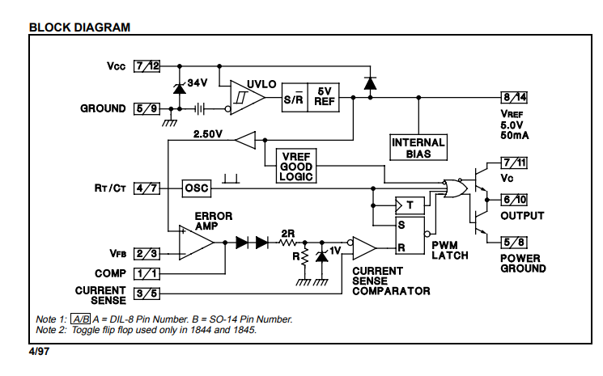

**Figure 15.** UC1845 Current mode PWM controller [3]

Simulation results of closed loop system are in following figure 16, 17, 18 19.

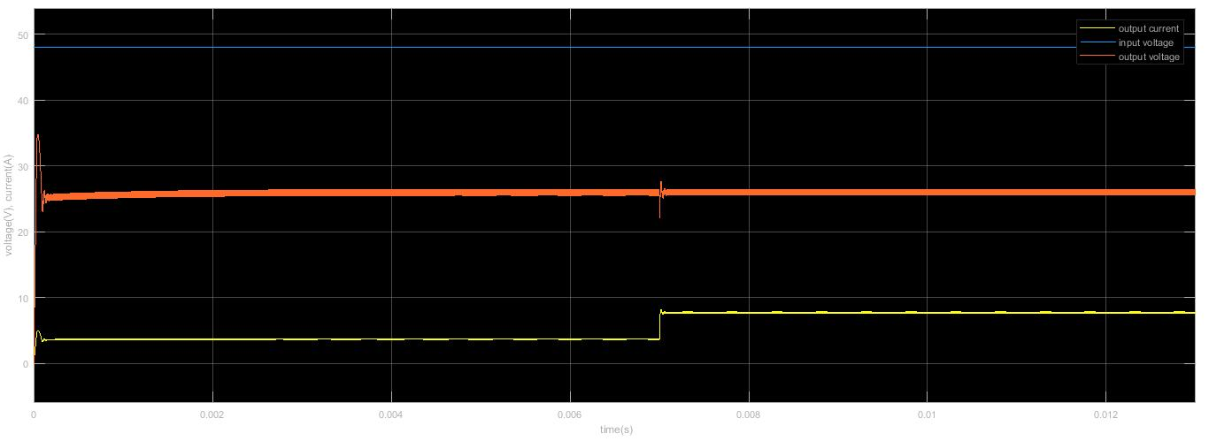

**Figure 16.** Response of the system when load is decreased two times

Control effort is in following figure 17.

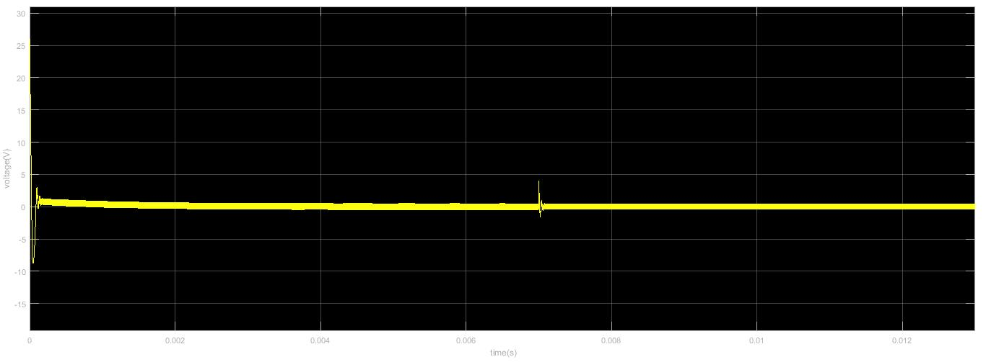

**Figure 17.** Control effort

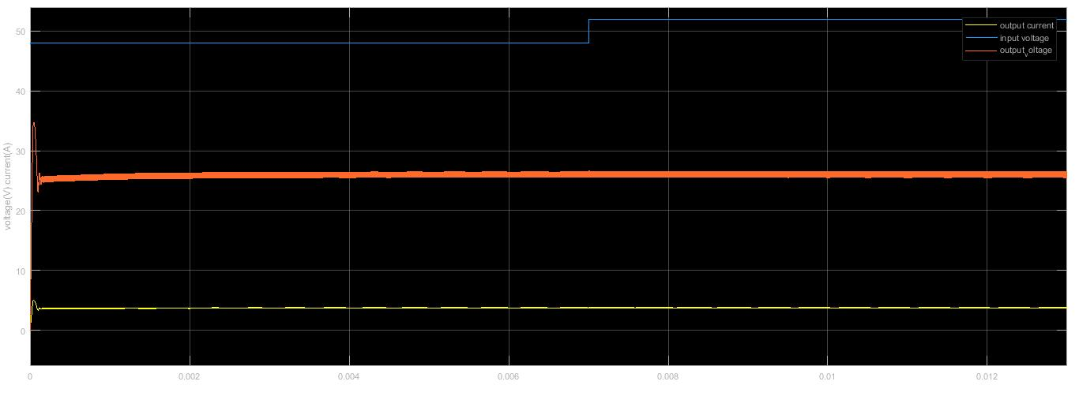

**Figure 18.** İnput voltage is increased %10

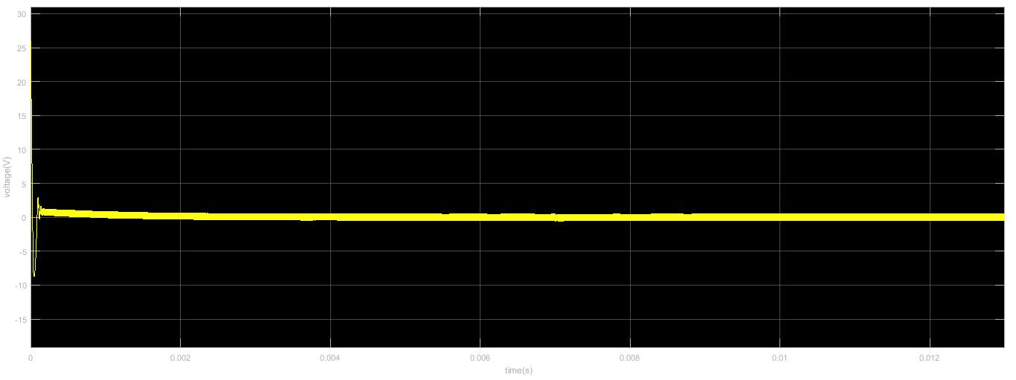

**Figure 19.** Corresponding control effort

Figure 16,17,18 & 19 show us our controller works efficiently and control effort voltage is in the applicable levels.

**3. Demonstration Results**

**4. Conclusion**

This project was a good opportunity to apply our knowledge which we gain from the course to real problem. We designed a Forward Converter and a controller circuit. We observed that in real life applications, it is not enough to have well theoretical backgrounds, there is always a possibility to encounter unexpected problems during design process. We overcome these problems by making some research on the internet (by asking people who worked on similar projects) and making some library researches. In addition to Forward converter we designed a controller circuit to stabilize the output voltage level in case of any fluctuations.

To conclude, this project was a good opportunity to check our knowledge before encountering the engineering life and we hope that solution methods and design process in this project will find an echo in the field of power electronics area.

**5.References**

**[1] Ferroxcube, 2008. Retrieved From (pdf):** [**http://www.farnell.com/datasheets/1481602.pdf**](http://www.farnell.com/datasheets/1481602.pdf)

**[2] Texas Instruments, Jan. 2017, Retrieved From (pdf):** [**http://www.ti.com/lit/ds/symlink/uc1845.pdf**](http://www.ti.com/lit/ds/symlink/uc1845.pdf)